Main Code

*In this code there are a lot of functions that are self-explanatory and don’t really need explaining, usually short getters and setters. *

Shader Class:

This is the Shader Constructor Method. This takes in a string which is the filepath of the “shader”.glsl file. This method loads all the data from the file into a string. The string Names Source is split up using regex into 2 parts. In OpenGL shaders have a Vertex and a Fragment part to the shader. the Source is split into theses two parts. If the file does not contain Vertex/Fragment the shader will not work so I added an error Message “throw new IOException” so if that error happens the user know why. I also put a Try Catch around this so if an error occurs, a StackTrace is outputted for this to show the line the error occurred in. The error will also cause a false assertion with an error message telling you that there was an error with the shader file. This also forces the program to stop as if the shader error, then nothing can be rendered to the display. When the code error I also output the reason why it errored as to make it easier for the user to fix the problem in the shader file.

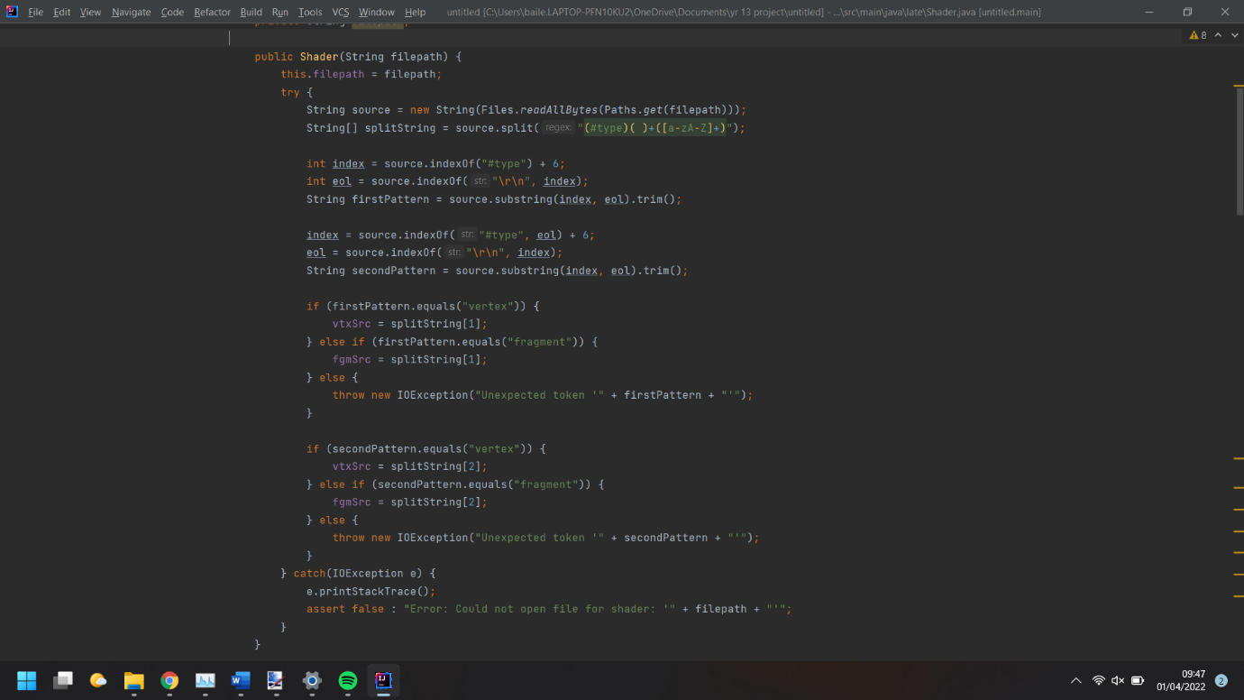

Shader Compiler method:

In this method the shader is compiled. In openGL you need to compile shaders in parts, then linking them. For example, The Vertex Shader is generated In glCreateShader() giving it the OpenGL id for a vertex shader creation. This returns the Id of the generated shader so you can upload data to that shader. the shader is then compiled. I error trapped this by after compiling the shader, you can get the status of the compiled shader. If the returned value of the status is returned as an integer. If the returned value equals the OpenGL false id, I output the error with the filepath of the shader so if multiple are in use the user knows which one is causing the error. I also output the Infolog of that shader for more information on why the shader failed to compile. The program then halts as if the shader fails, objects cannot be rendered to the screen, meaning the user may get confused if the code continues to run but just displaying a blank screen. After each part of the shader is compiled, I create a new GLprogram which can have each shader attached and linked. If this fails, the program will error as well telling the user why it errored and halting the program. The shader_ID is stored as it is a reference to the shader you want to use so when rendering you need to tell OpenGL what shader to use to render.

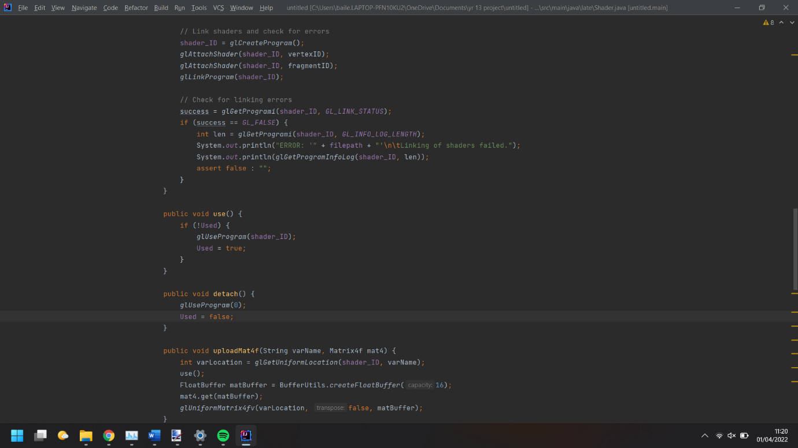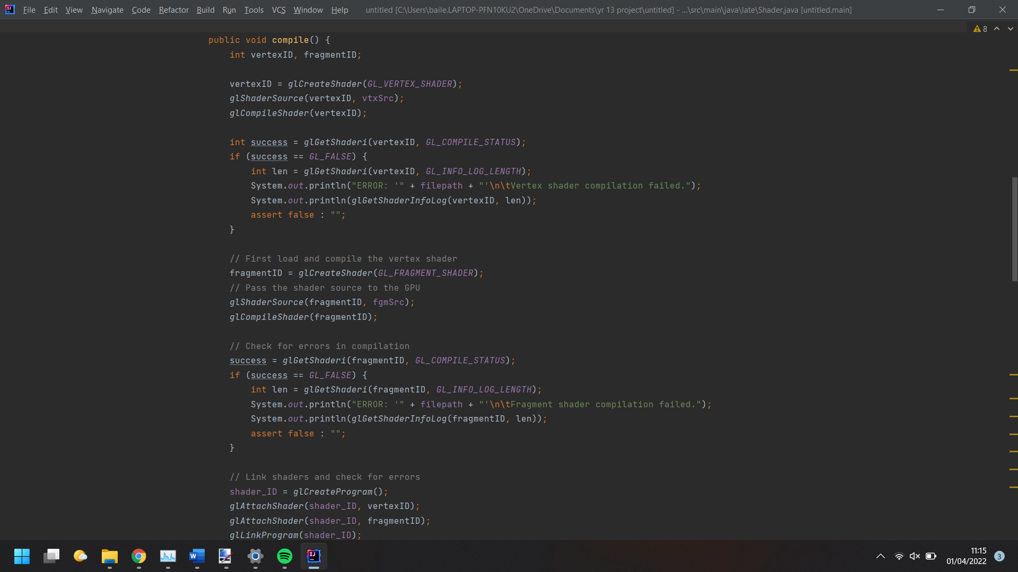

Shader Use and Detach Method:

For these methods, the use() method, checks if a shader is in use. If not, it tells OpenGL to use the shader with the id generated in the Compile() method. For the Detach() method, this just tells OpenGL to use a shader with id 0. 0 is used to tell OpenGL that we want to remove the current shader in use.

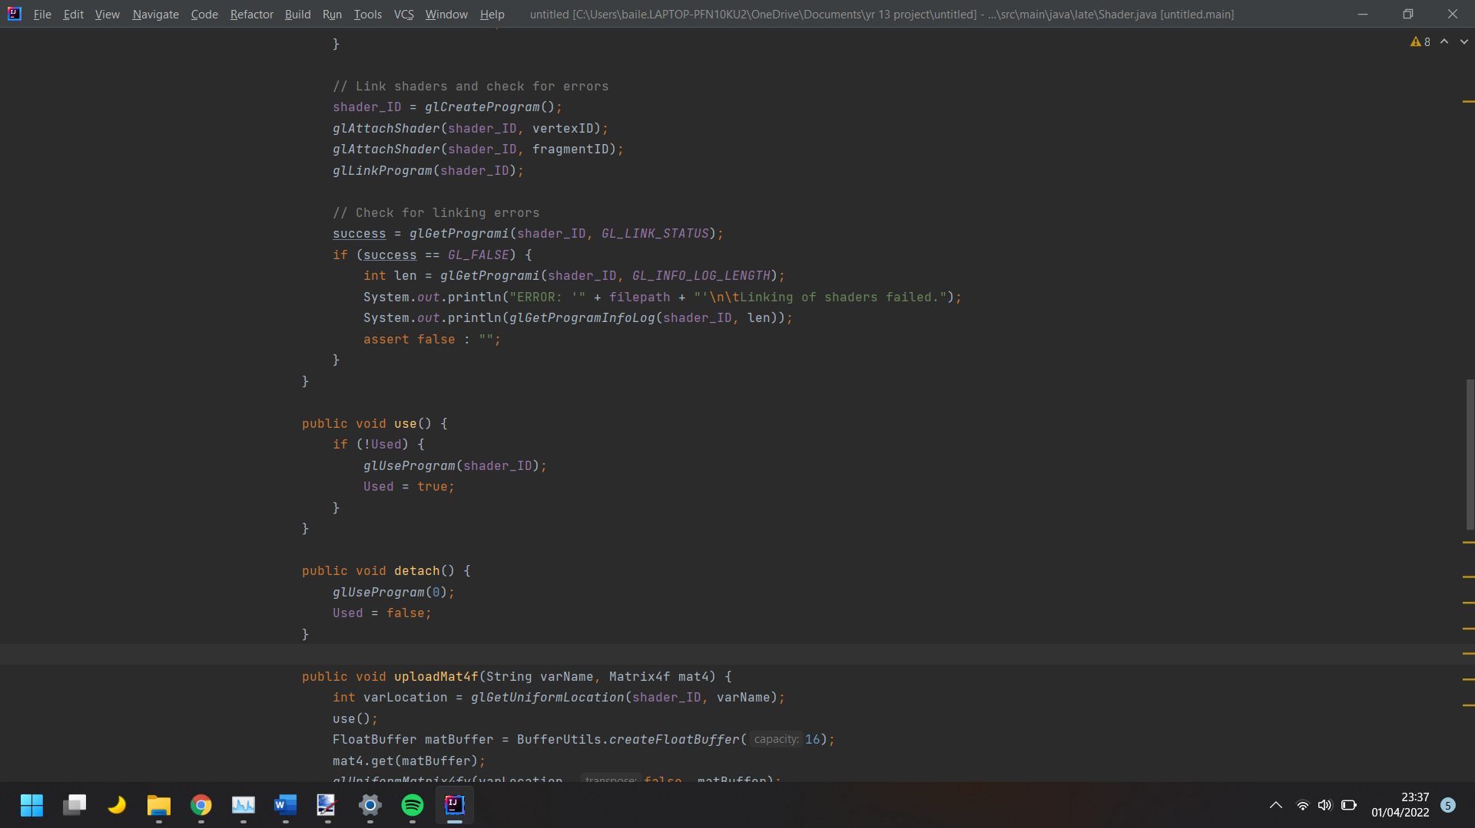

Shader Uploads:

When using shaders, you need to upload data to the shader for each object being rendered. I created a lot of methods for uploading different types of data to the shader for rendering. Each upload method is very similar. These check what attribute you are uploading to the shader, returning a location integer. An OpenGL method is then used, depending on what data is being uploaded, taking the location and data parameters.

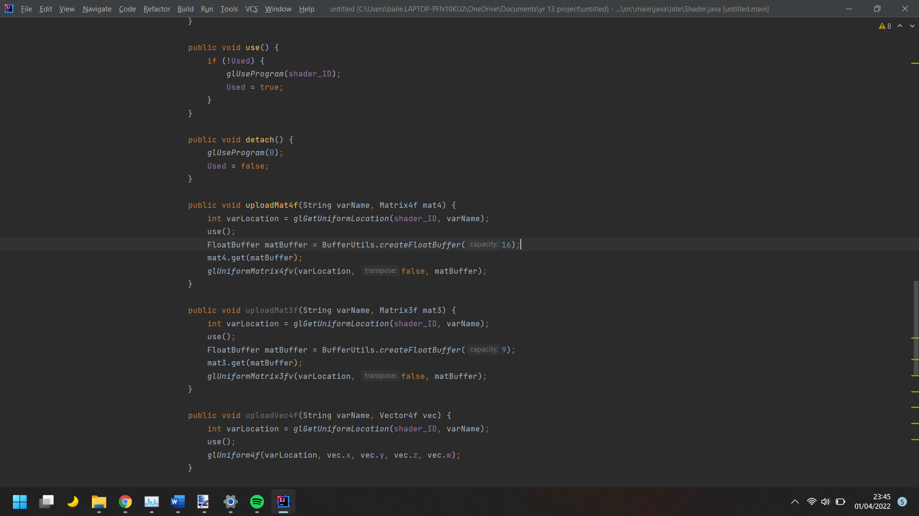

More info on OpenGL documentation at https://docs.gl/

Rendering Class and BatchRenderer Class:

These classes work together to render objects to the screen. I use a technique called batch rendering when rendering to the screen. I did this as it would be very inefficient to render each object at a time. In batch rendering you group like objects into a massive array. I set each array to hold 1000 objects, meaning the actual length of the array must be (in my case) 10 times that length. When rendering objects to a window the gpu will draw triangles to represent everything, so if you want to render a square you need to create 2 triangles. To do this I store the point of each triangle per object, as well as its colour, texture Coordinates and textureID. This is the reason for the massive increase to the array length. For Example:

P1 P2 when rendering you would upload data to the shader as =

P3 P4 {P1,P3,P2,P2,P3,P4,C1,C2,C3,C4,T1,T2,TID}

The first 6 values in the array are the point of the 2 triangles to make the square. That is followed by the colour of the object. Represented by {Red, Green, Blue, Opacity}, each value being between 0 and 1. Then there is the texture coordinated. These tell the shader what part of a texture to render onto each object. Finally, we give it the textureID, telling the shader which texture to use when rendering.

When starting the batchrenderer class you need to tell the gpu a lot of information. Firstly, A Vertex Array Object is generated and returned an id as a reference to the object. Then a Vertex Buffer Object is generated. this is used to buffer all of the data of each object to the gpu which can then use this data to render the triangles. Then we generate an Element Buffer Object. This is used to tell the gpu how to draw each triangle. Next, we need to tell the shader and gpu what data will be in the VBO. We do this by creating an attribute pointer, giving each part an index, the size of this part in the array, its variable type, if the raw bit data is normalised, the stride (the gap between each objects data), and the offset from each base stride. We then enable the Attribute inputting the index of the Attribute pointer. This is repeated for each part of the objects data

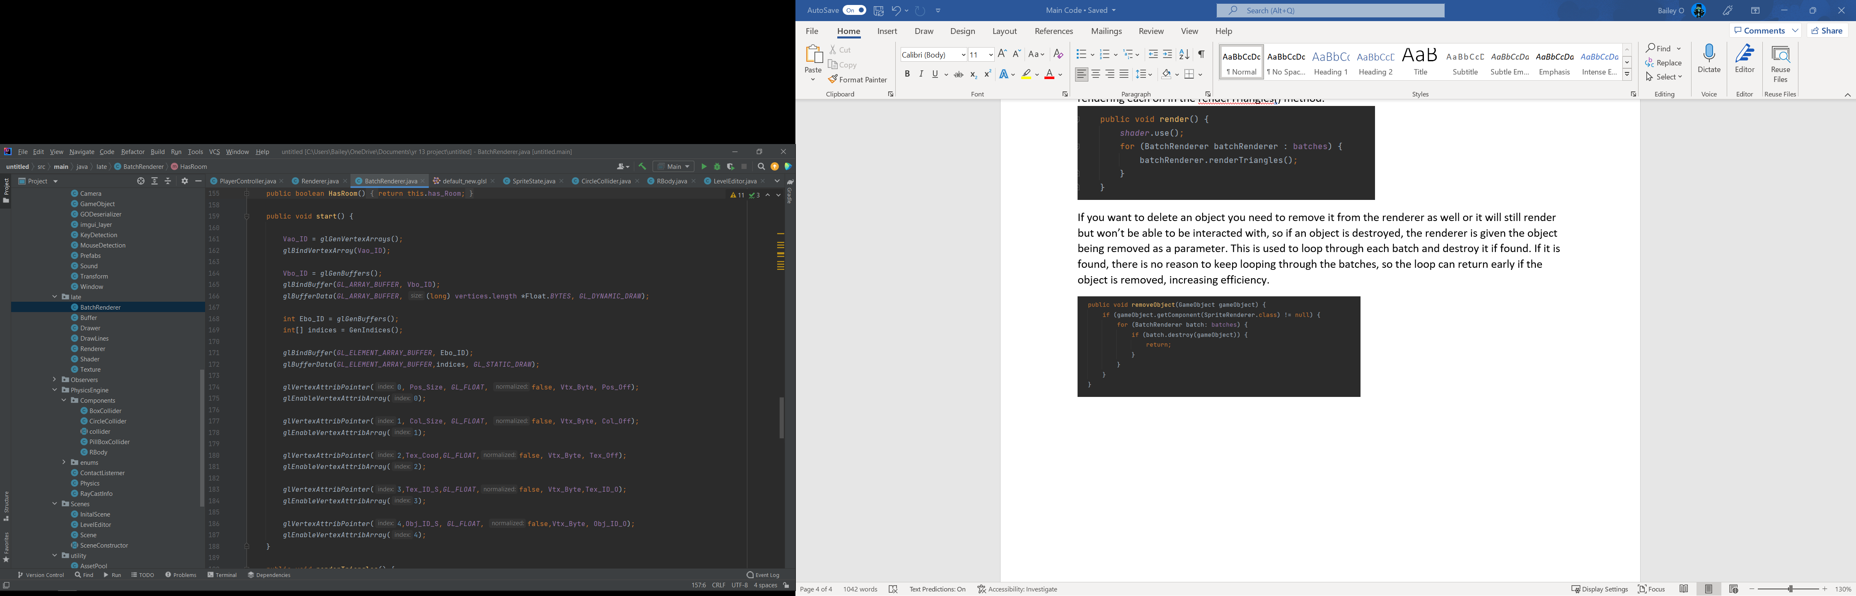

How the Shader Works:

For the indexes from the attribute pointers in the start() method, the shader is given the data at these points. You can then code how the shader uses these values in the main() method. When coding the shader you must tell it what data it is expecting in to the vertex shader and what values it will output from each part of the shader. For example the vertex shader outputs fColor, fTexCoords and fTexID. These three values are then input into the fragment shader which can use them to output a final colour for each pixel.

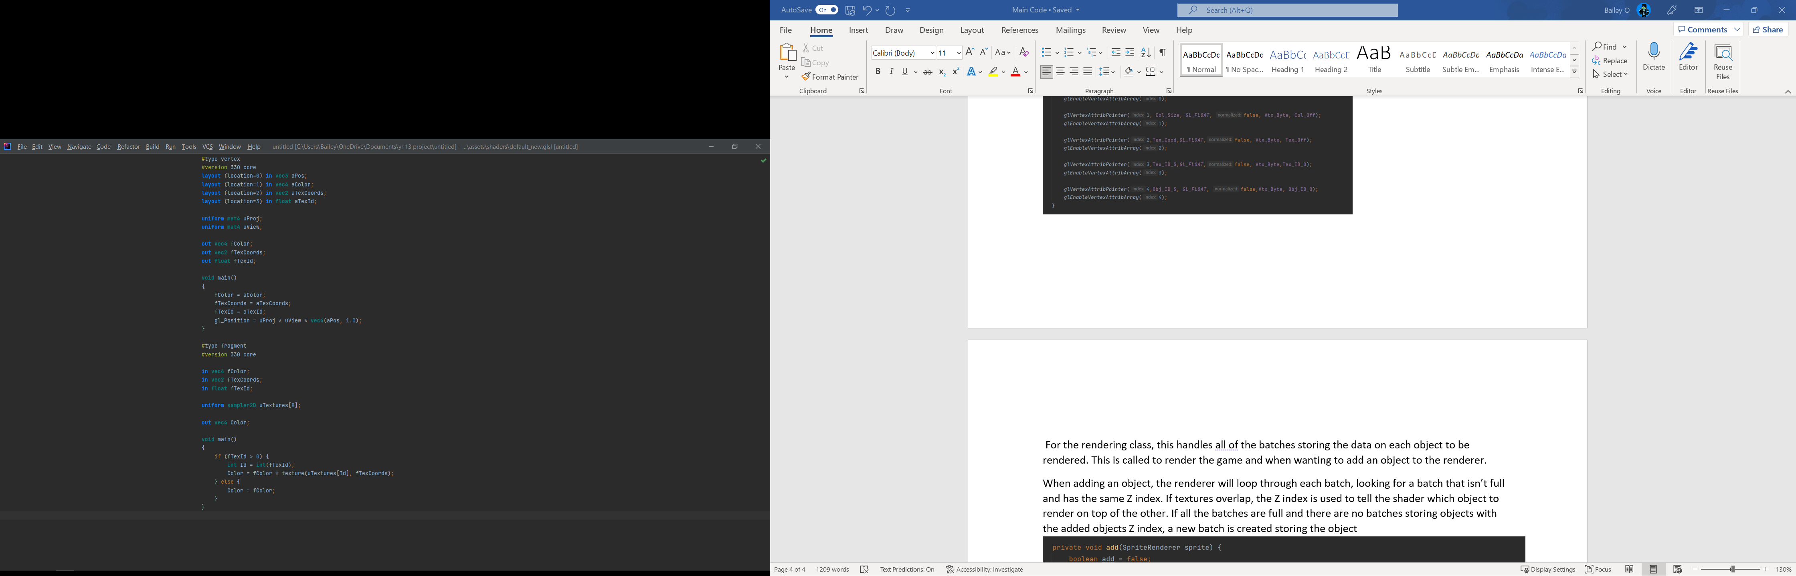

For the rendering class, this handles all of the batches storing the data on each object to be rendered. This is called to render the game and when wanting to add an object to the renderer.

When adding an object, the renderer will loop through each batch, looking for a batch that isn’t full and has the same Z index. If textures overlap, the Z index is used to tell the shader which object to render on top of the other. If all the batches are full and there are no batches storing objects with the added objects Z index, a new batch is created storing the object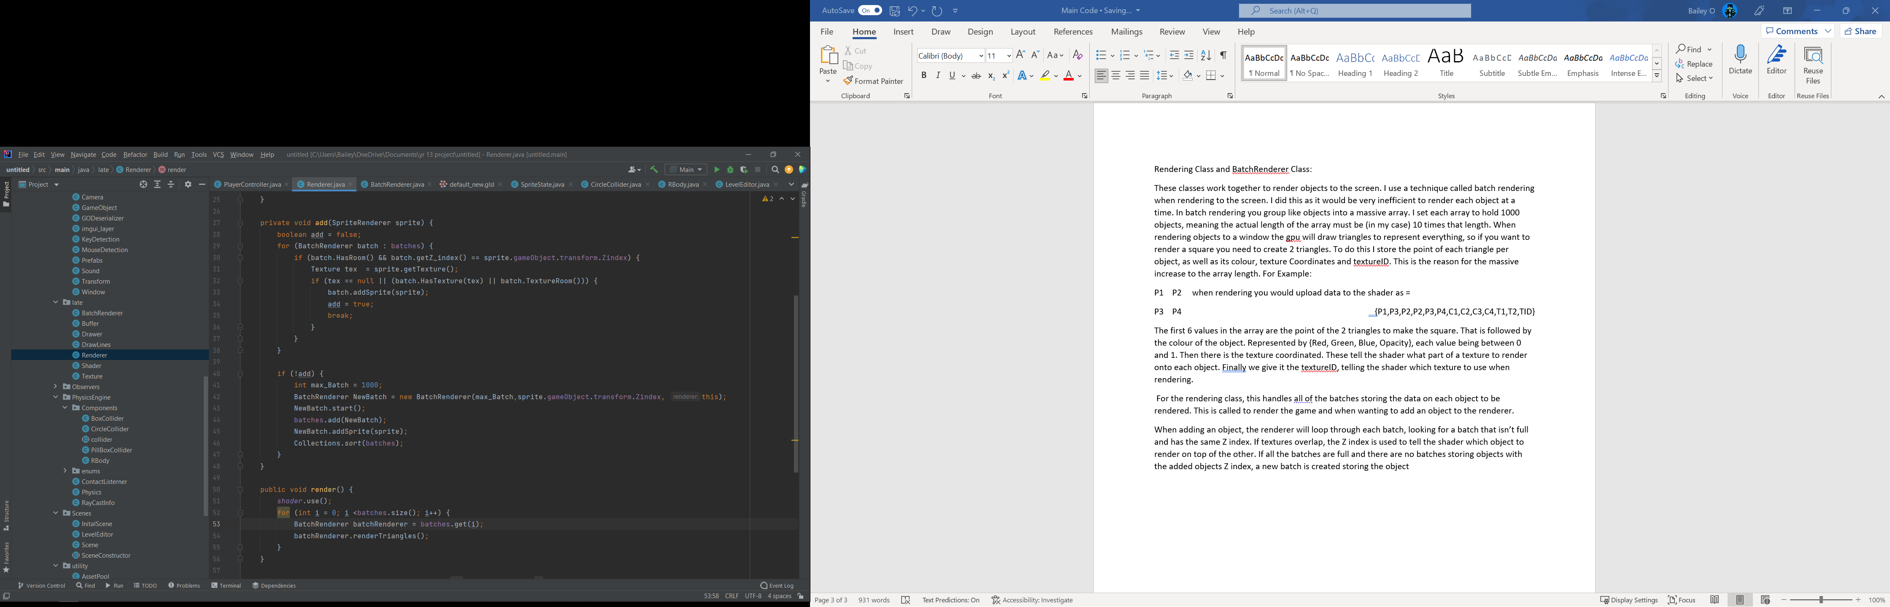

The render method tells OpenGL to use the shader loaded, the loops through each batch in batches, rendering each on in the renderTriangles() method. 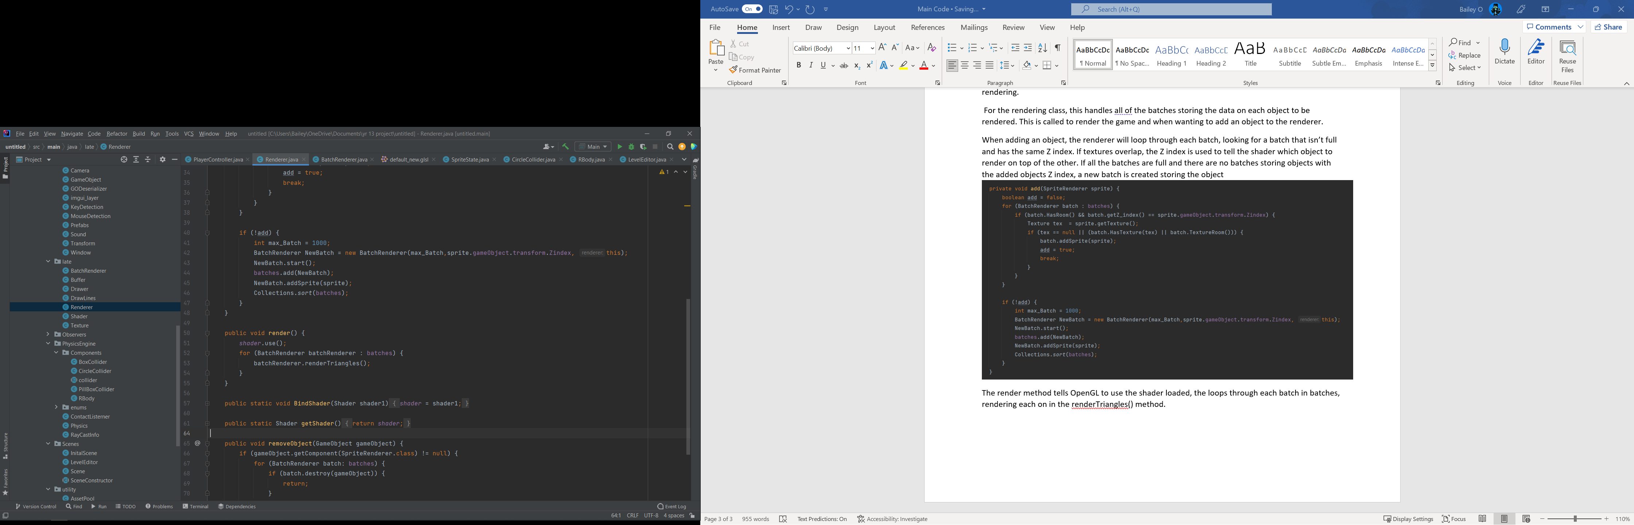

If you want to delete an object you need to remove it from the renderer as well or it will still render but won’t be able to be interacted with, so if an object is destroyed, the renderer is given the object being removed as a parameter. This is used to loop through each batch and destroy it if found. If it is found, there is no reason to keep looping through the batches, so the loop can return early if the object is removed, increasing efficiency.

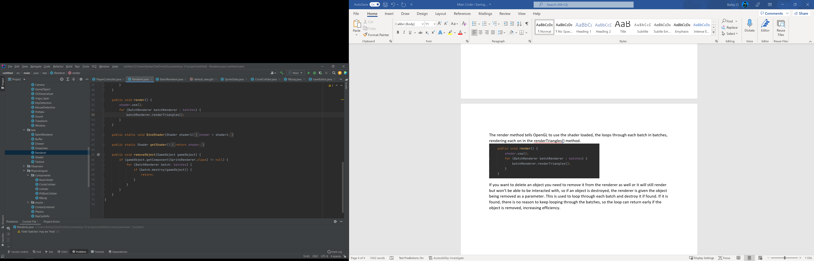

Texture Class:

Init() method:

For this method it load a Image File onto the GPU memory. Firstly a file object is created to see if the file exists in the directory. When saving the game each texture is saved with the filepath to the image file. If the main file is moved to a new directory, the filepath of the saved textures will not update so I implemented a check to see if the file had been moved. If the Image still doesn’t exist then the code halt outputting that the image file trying to be loaded does not exist. If the Image exists, we create a GLTexture object. Then we tell OpenGL that the texture is 2D. then we give the texture parameters, telling it what to do if the texture is to small for the objects surface, telling it to repeat the texture. We also tell it how to scale the image up and down, as this project is aimed at creating pixel art style games, I used the linear upscale and downscale. This means there is no blending between pixels and no anti-aliasing performed on the texture as with a pixel art style that would make the textures appear blurry and low quality. Now the image need to be loaded into the project. This is done with an stbi library. This will load the texture into the project. The image is loaded as a long array consisting of {R,G,B,A…} or {R,G,B…} depending on if image file loaded has a transparency variable for each pixel. The image now must be added to the GPU through OpenGL. When adding it to OpenGL you need to specify its array format. If each pixel has 4 attributes, then you tell OpenGL this by passing the RGBA key for that format. I checked this ass it reduces errors as if the user wants to add a .jpg or .png, there should be no problem loading. If there is an error with the array format, the program halts, and outputs an error telling them this problem. Finally the stbi image is freed, freeing the memory it was taking up.

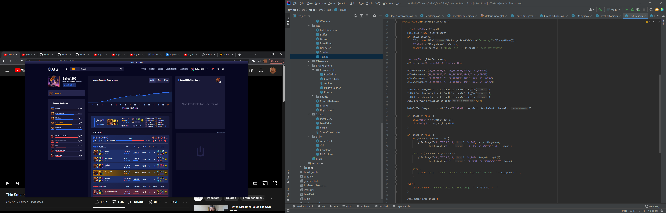

Scene Class:

Save() and Load() methods:

To Save objects to a text file, I am saving them in the Json format. I serialise the objects using serialisation by reflection. This is achieved by using GSON library. To do this you create a Gson object. When creating the gson object you enter parameters for what classes to serialise, and if there are any special requirements, for example enableComplexKeySerialization() (for hash map serialisation). After this is created, a FileWriter is created to save the objects to, giving it the file to save to. Then a new Arraylist is created, containing every object to serialize. I did this check as there are some objects created to handle the GameEditor (grid lines camera etc), not needing to be serialized. Then the gson object is used to convert this array of objects to the long string in the json format. This is wrote to the save file and then the file is closed. This is repeated for the Objects in the import window as to separate them from the objects in the main game. For the load method, this also uses Gson. A new Gson object is created, passing in the Converter and GODeserialzer classes (explained below). Then the save file is read, loading all of the json format text into a string. This is put in a try catch, so if there is an error loading the file the user will be shown and nothing will be loaded. If the file is loaded, the filepath string is verified that it contains so string and is not empty. if it isn’t empty, then the objects are deserialized and stored into an array. This deserialization uses the converter and GODserialzer to create game objects form the json data. This is then repeated for the file containing the import objects, adding them to a separate array.

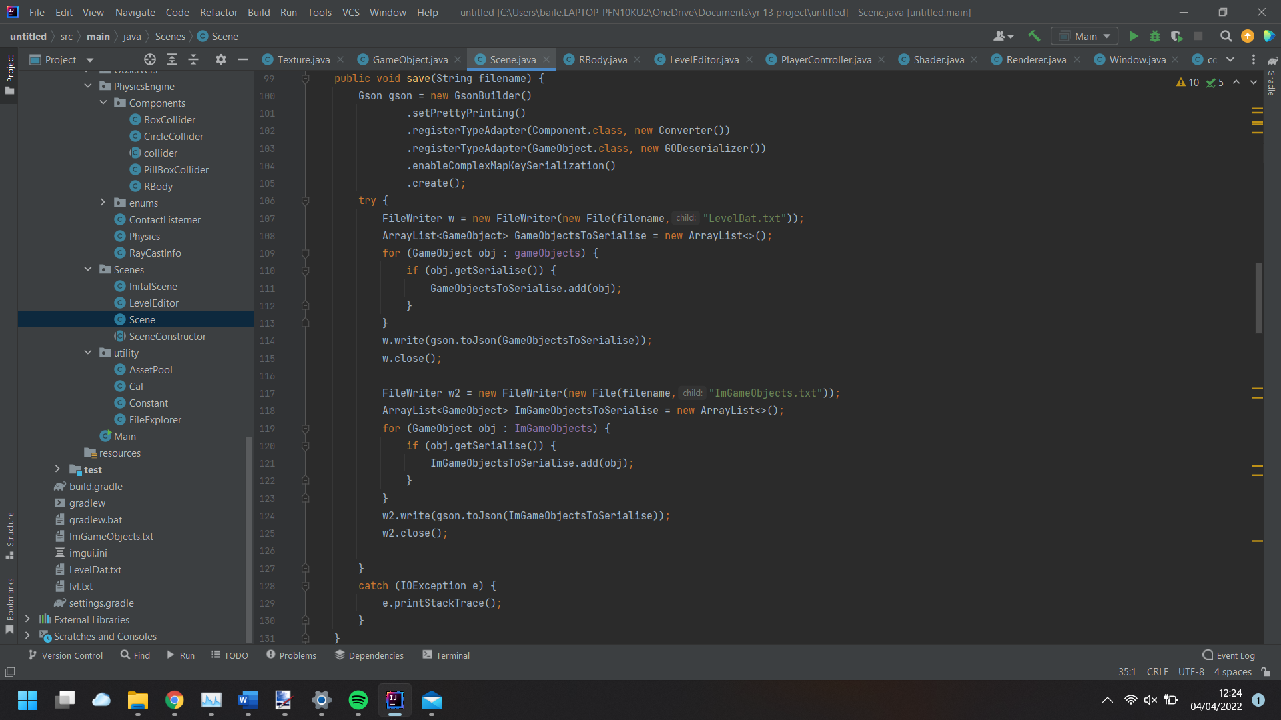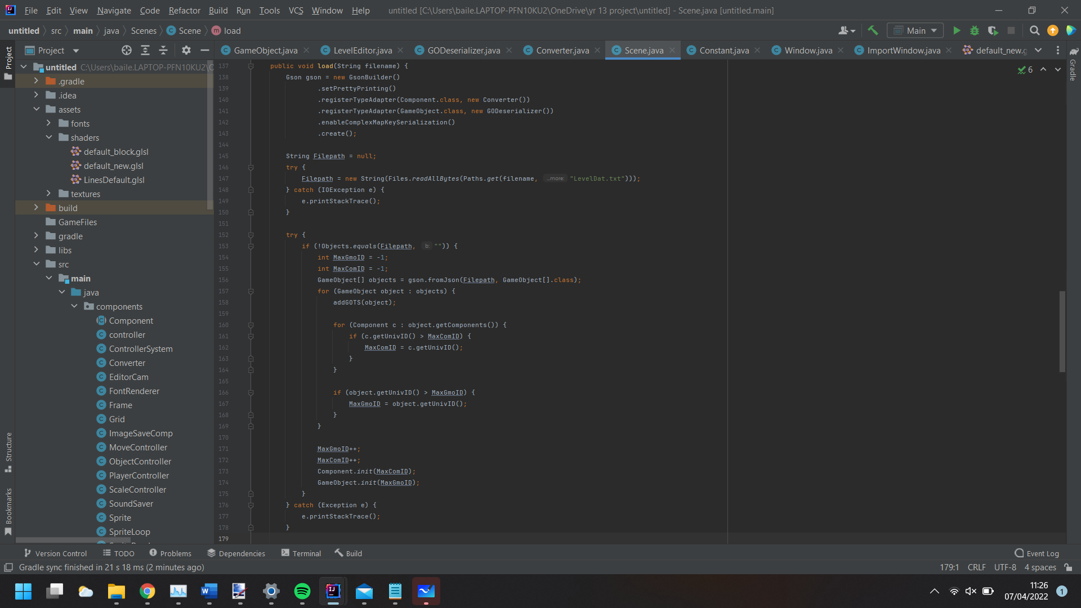

Converter Class:

This class is passed into the Gson object. This tells gson how to serialize and deserialize all of the Component Classes (Classes that extend component). This class implements JsonSerializer and JsonDeserializer with the component passed into it. The serialize and deserialize methods are overridden, serializing and deserializing the way I want.

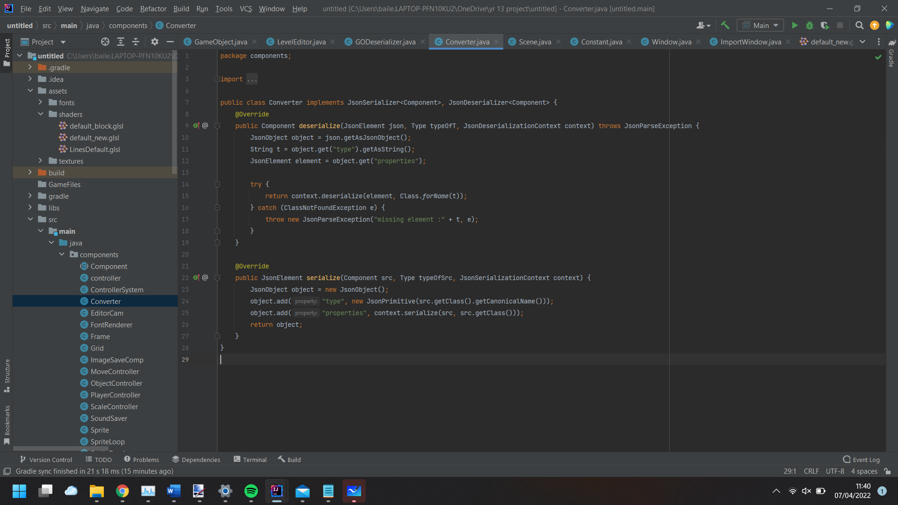

GODeserializer class:

The same as the Converter class the GODeserializer class is passed into gson telling it how to deserialize GameObjects. This class, however, only impelments the Deserialize method. When deserializing a GameObject, a new GameObject is created, passing in the tag from the serialized GameObject. Then the components are deserialized and added to the GameObject. Finally a reference to the transform component is assigned in the GameObject object, so its easier to access the position scale etc. of the object without having to retrieve the component each time. This is done to hopefully reduce the computation of the code each frame and increase the efficiency of the code. The gameObject is then returned.

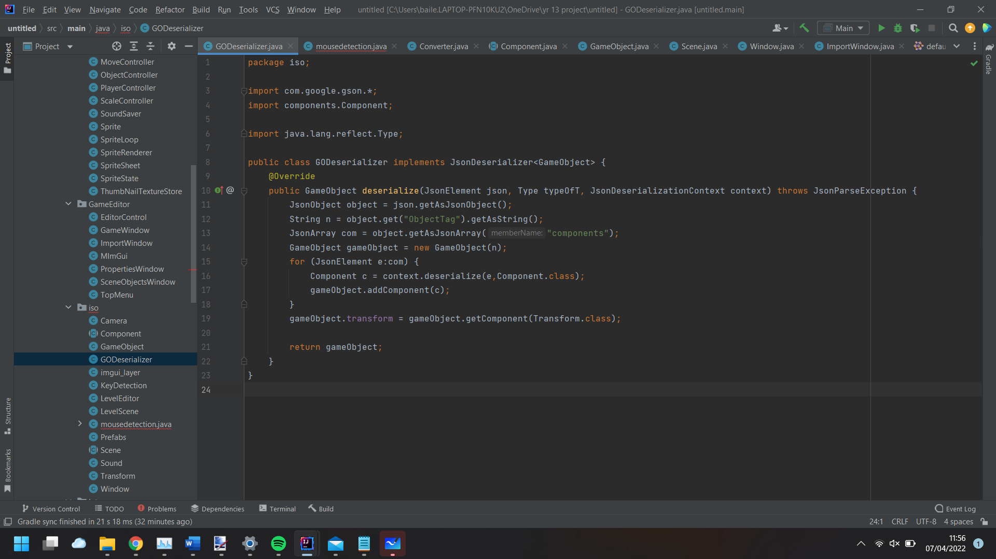

Window Class:

This class handles the main loop of the code. This also contains all of the initialising OpenGL, OpenAL, imgui (window handler), and creation of the window. This class also handle all the scene management and when System Events happen i.e., save button pressed. This is done through the Observers package (explained later).

Init() method:

Firstly, glfw (OpenGL java library) is initiated, if this fails a IllegalStateException is thrown. This may be because the computer doesn’t support OpenGL, or the users OpenGL version is not supported etc. then we give set up window flags to tell OpenGL what the window will be capable of. For example, glfwWindowHint (GLFW_RESIZABLE, GLFW_TRUE). This tells OpenGL to set the window to be resizable as we gave it GLFW_TRUE, which is an int value OpenGL has assigned to represent false in their libraries. After setting the appropriate window flags, the window is created. This is stored in the Long variable glfwWindow. If the window creation fails, glfwWindow is set to the OpenGL Long value for NULL. This is then checked and an illegalStateException is thrown telling the user that the window creation failed. Then the mouse position, Mouse button pressed, Mouse Scroll, Key pressed callbacks. When one of these is triggered, for example, the mouse is moved. By setting up this callback, the mouse position is updated in the MouseDetection class. Then the glfwMakeContextCurrent() is called with the Long Window Value. This tells OpenGL that this window is the one that we currently want to use for functions etc. the glfwSwapInterval(1) means that the window will refresh at the screens framerate (Vsync). Then the window is displayed. Now the audio (OpenAL) needs to be initiated. Firstly, the current default audio devices name is requested and stored as a string. The audio device is stored as a Long value in audioDevice. This is done by telling OpenAL what audio device we want to access, passing the name of the audio device from the previous line. Then the audio context is created passing in the attributes (for this project is none) and the audio device. Very similar to OpenGL, we need to set audio context to current so we can use it. Once this is done, we create capabilities for this audio device. Finally, we create AL capabilities, telling us what this audio device is capable of. We check to see if the OpenAL version is higher than OpenAL10, erroring out if it is outdated. Then we create Capabilities for the window, telling it to blend transparent colours and how to blend them. Then an instance of the imgui_layer is created and initiated. A framebuffer is created to be used in imgui as the viewport.

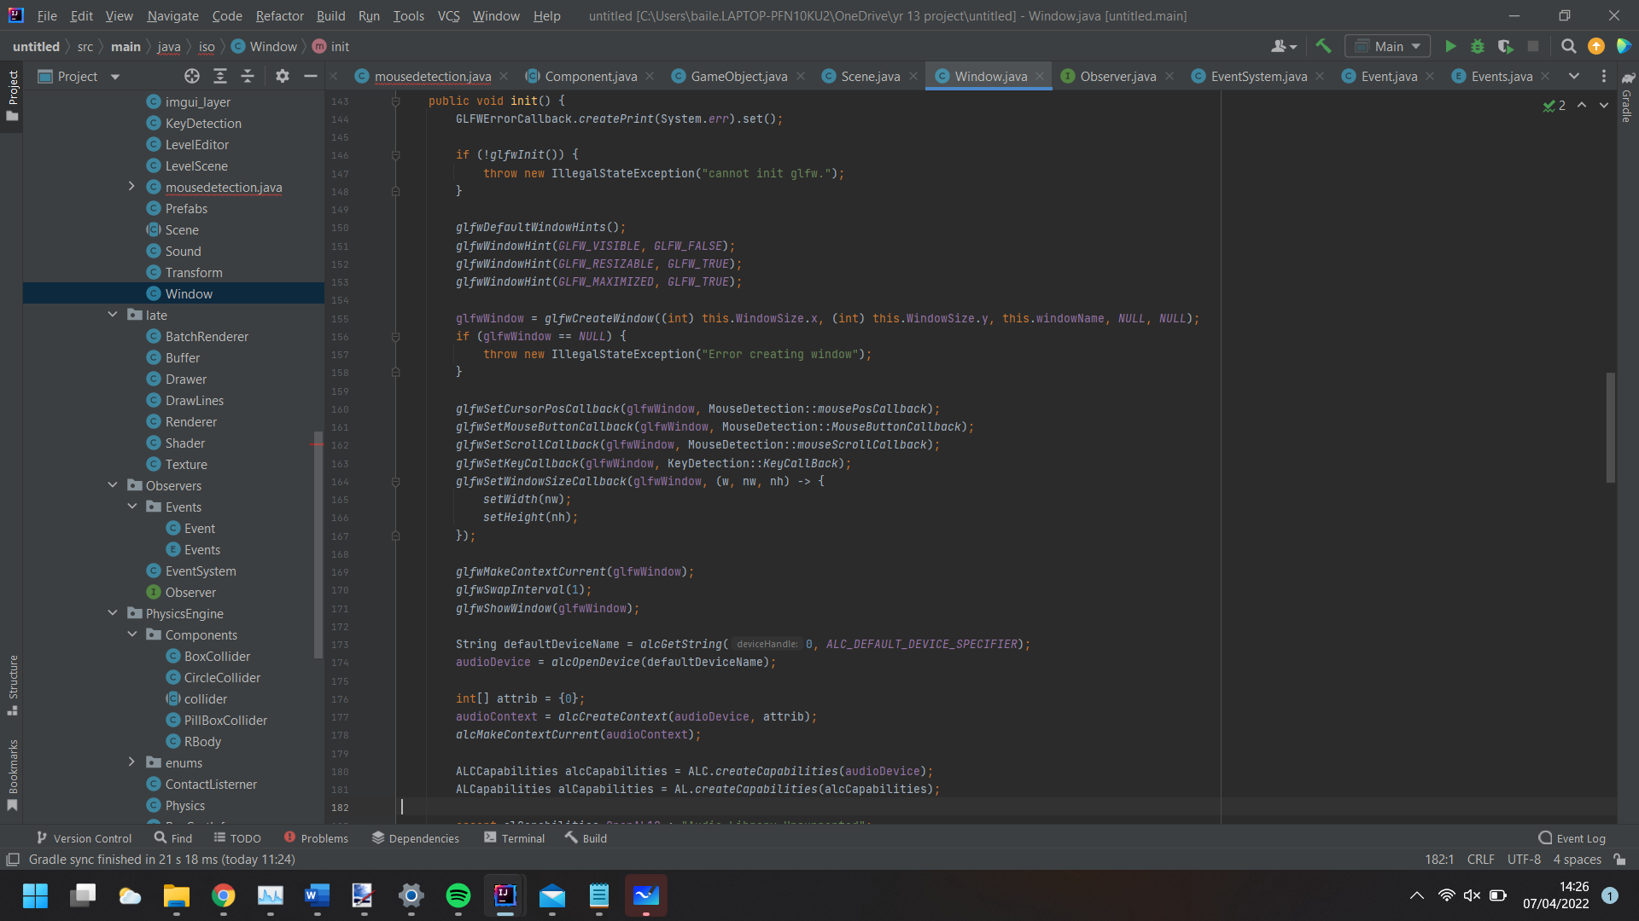

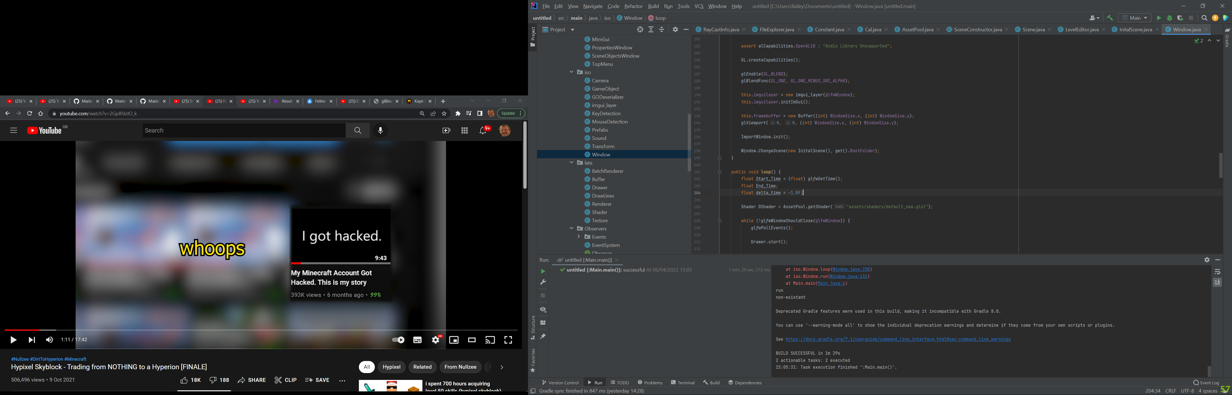

For the Loop:

When called 3 float varibales are created, Start_Time, End_Time, delta_time and a Shader instance is created. The main loop will run until the user presses the X button on the window, halting the program. While in the loop the glfwPollEvents() is called each frame, updating all the callback processed we setup in the initializer. The drawer is started. This class is used to draw the lines, boxes and Circles onto the window. Then the framebuffer is binded to OpenGL. Then the screen is wiped of colour and set to white. Then delta_time is checked to make sure it is greater than zero as it is expected to be greater than zero in the methods it is passed into. If passed in as a negative number there could be errors with calculations using it (i.e physics). Then the Drawer draws all the grid lines, boxes and circles stored in its array to the screen. The shader loaded above is then passed into the renderer binding it to the gpu. Each function has 2 updates, an Editor update and an update method. These are used as some stuff, like grid lines, we want to render in the editor but when running the game we want to hide them. The scene is rendered. If the left mouse button is pressed getclicked() is called, setting the object clicked to the active, bringing up an inspector pannel, used to edit attributes of that object (like its position). Then the framebuffer is unbound and the imgui_layer instance is updated. glfwSwapBuffers() is called passing in the window. This updates the window. Then endFrame is called for the mouse detection and Key detection, reseting temperary values to their default. The deltatime (change in time since the start of the frame) is them caluclated and the starttime changed to the current endtime.

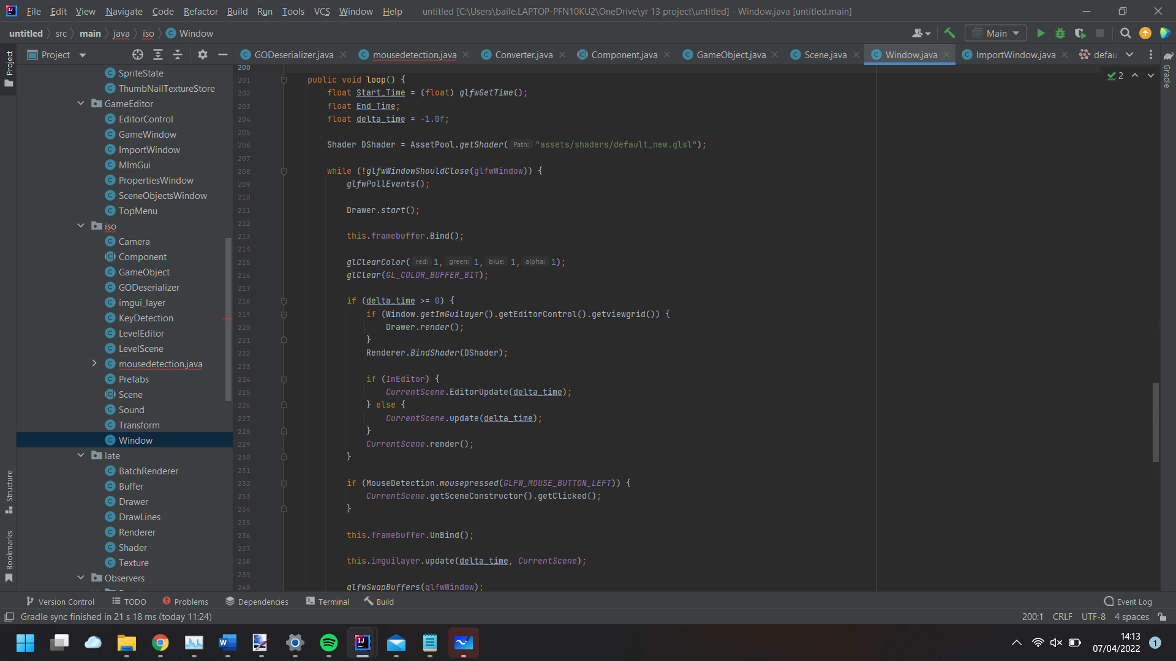

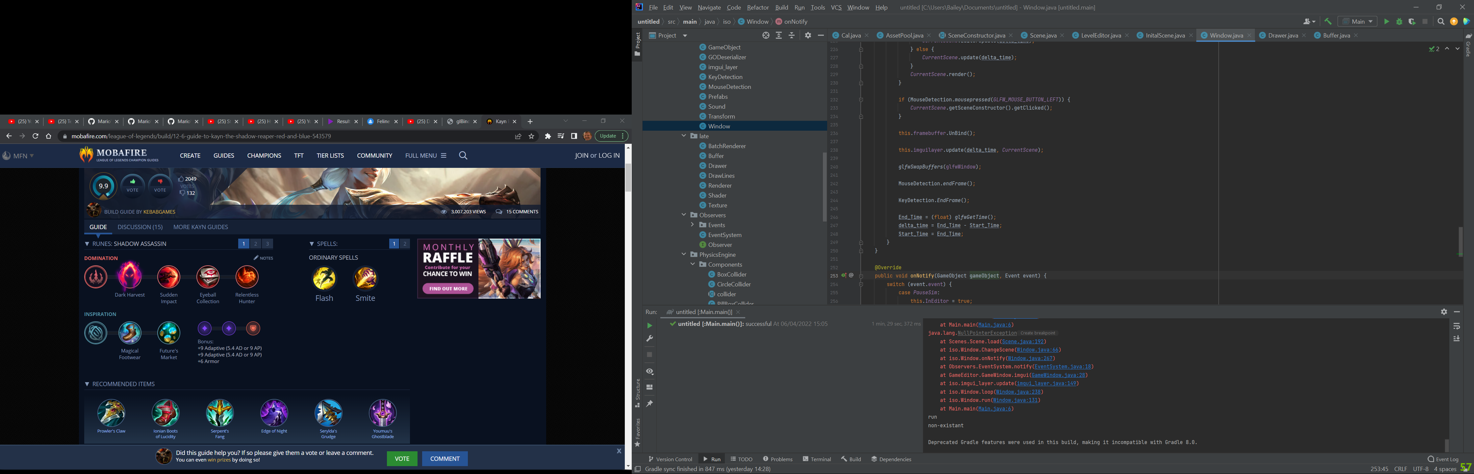

OnNotify() Method:

This is an override of the interface class observers method onNotify(). This gets the event that was triggered (i.e savelevel). This will go through each case checking to see if the enum event matches. If it does, then the code in that case is executed. For example, in the saveaslevel case, the fileExplorer is opened, returning a string for the filepath of the selected folder. I made it so you can only select directories when saving as errors would occur if the project tried to save to an existing file. If the user presses exit or cancels the folder selection the level is not saved. If a valid directory is selected, then the scene save() method is called, passing in the selected folder.

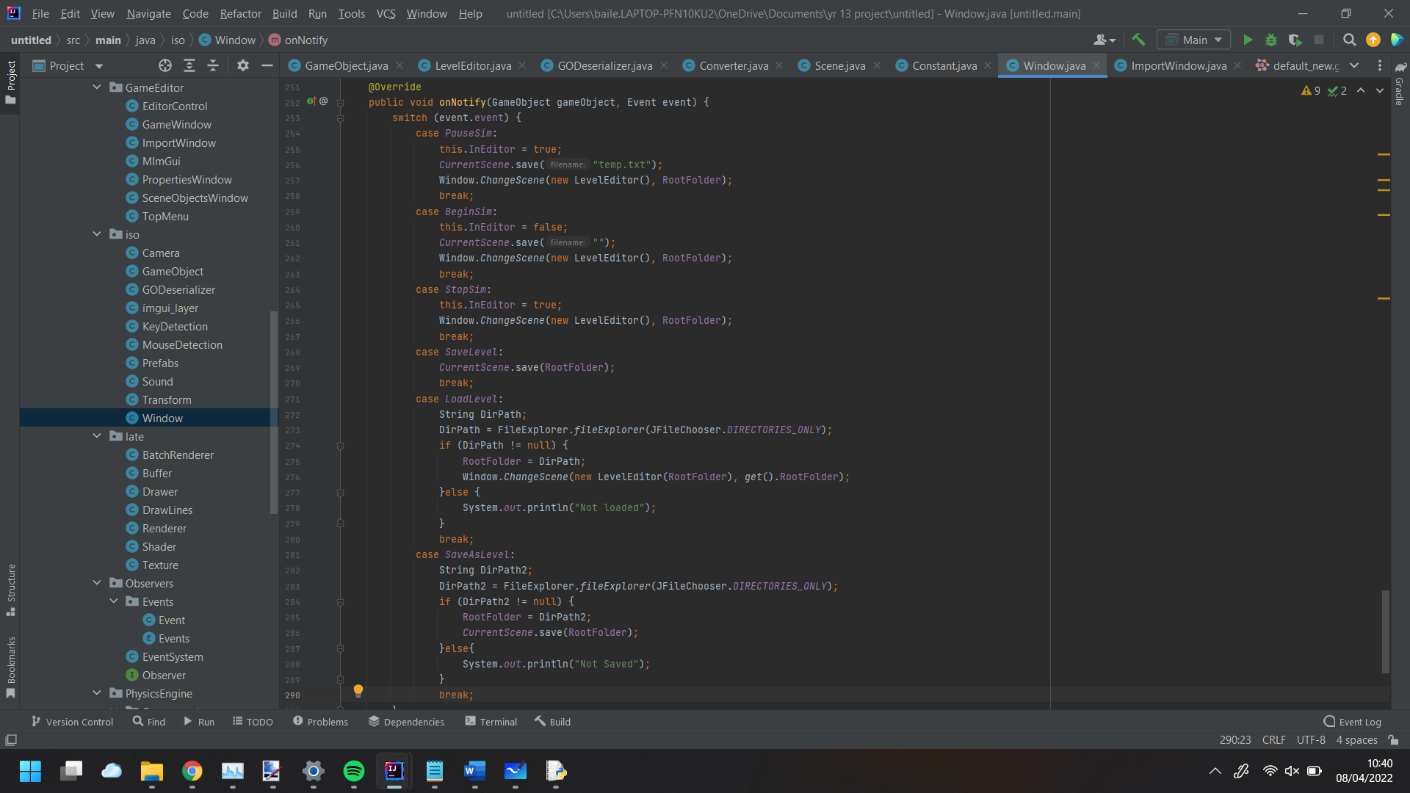

LevelEditor Class:

The use of this class is to handle all of the game management in the editor. This class is a subclass of SceneConstructor(). This is done so when going from different constructors they do not need individual variables storing their instance and can use a single parent class to store. This system used to not exist, and the scene class was a parent to the leveleditor class, where the subclasses would control most of the processes on the screen. I refactored the leveleditor class to work the way it does to make it easier for other people to edit and add to the source code if they want a more customised game engine. This also makes it easier when changing SceneConstructor as the Scene instance is not replaced with a new instance.

Init() method:

This is called when creating the scene constructor, setting up all the necessary variables and objects needed in the scene. Firstly, we assign a reference to the main Scene class so it can be accessed without going through the window class to retrieve a reference to it each time it is needed. Then a gameObject is created called Editor. This will store all the components used to control the scene. The controller() controls when an object is selected from the import window, moving it with the mouse. The grid sets up all the lines needed for the grid. The EditorCam is used to control the zoom of the camera and the position of the camera. The ControllerSystem controls how and which of the MoveController and ScaleController classes are used, switching between which is active and being used, when a set hotkey is pressed. Both controllers are subclasses of ObjectController. Then we set the EditorCam Class “displayImGui” to true. This allows us to have widgets of the variables stored in that class, excluding transient variables. 2 Boolean variables are created. These tell us if each gameobject respectively is found in the array of gameobjects. If these objects aren’t found, then new objects with these names are created. If these objects are found, then a reference is stored to them so it is easy to access them without having to do a linear search each time we want to use them. These are used to store images metadata used in the creation of a spritesheet and the creation of a sound, stored in components added to these objects. If these objects are found each sound/image save component contains the file name as well as the variables used to create it. Then for the root folder, all the files are loaded into a file array. This is then looped through with the components being looped through as well. A check is made to make sure the component is the right subclass and if the filepath stored in the component is equal to the filepath of the file. If this is the case then a new spreadsheet/sound is created.

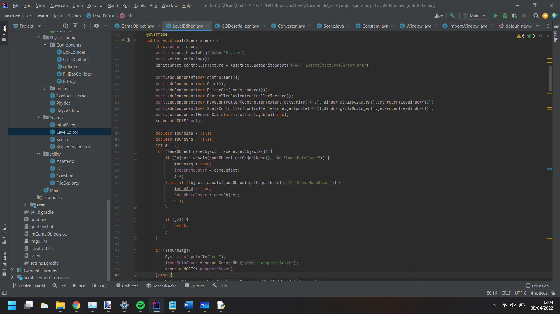

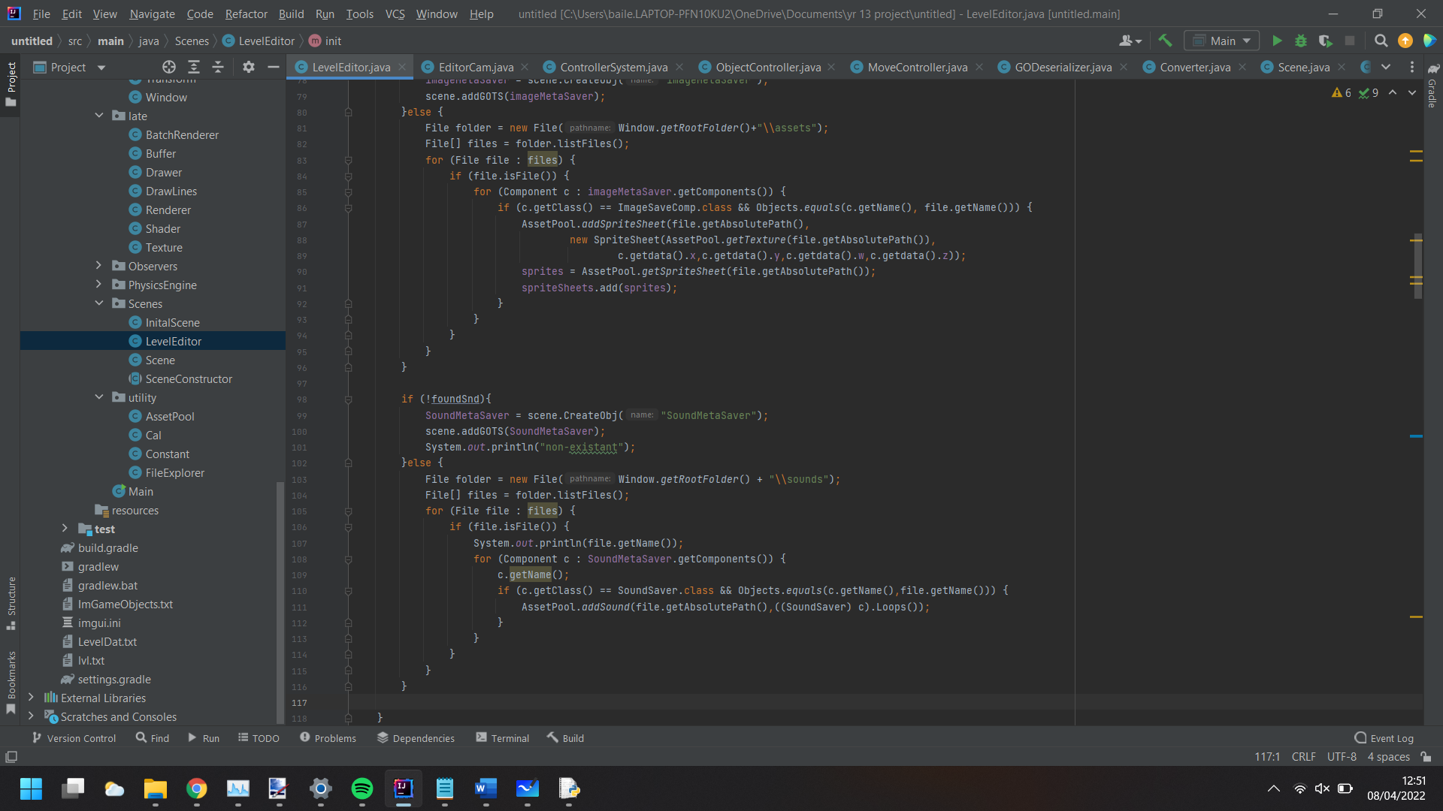

GetClicked() method:

This method is for when you want to select an object in the viewport. Firstly, the location of the mouse is calculated for the viewport. This is done as the original mouse position is used for the entire window whereas the viewport is a smaller part of the window, so the mouse position must be calculated to match where it would be in the viewport.

Mouse Position Calculation:

This first calculated the mouse position from the window width/height in pixels to -1 to 1. Then this is scaled up onto the viewport size multiplying the x and y values by the camera’s projection matrix and view matrix, returning the x and y values.

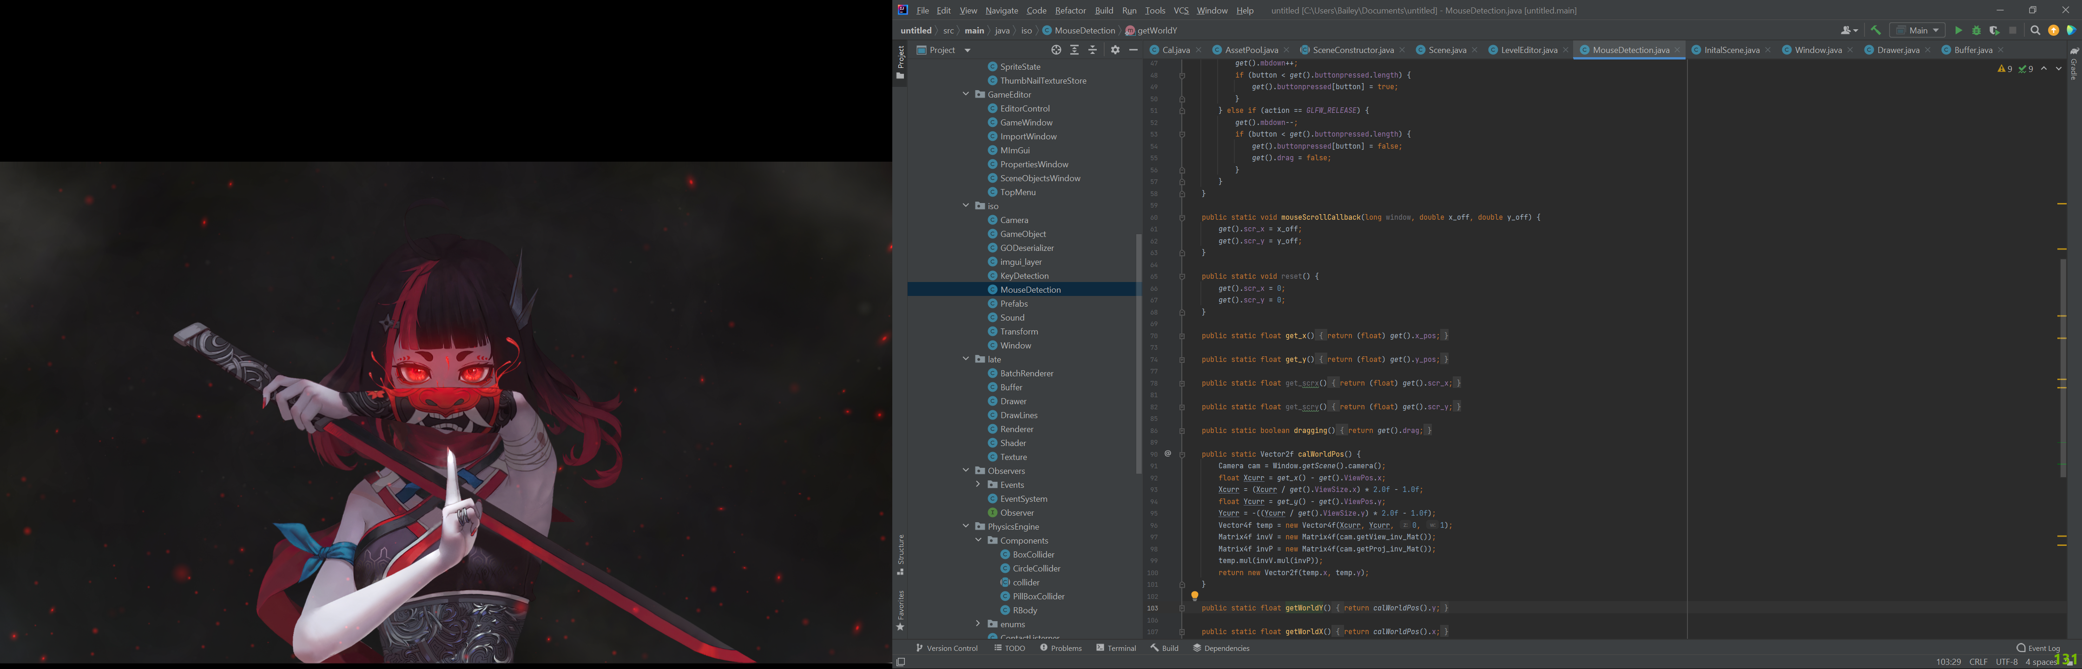

GetClicked() method again:

Then a check is performed to see if the user was trying to click the current active objects movement/Scale controller is being used to transform the current object around the viewport. If they are not in use then a linear search is performed on the gameobjects list. Firstly as you can have multiple objects on the same level with different Z values, the current Z value in use is the checked against the objects Z values, only checking objects on the same Z position. Then the objects position is checked against the mouse position. If an object is found, the colour of the object is changed to have a yellow hue, showing that it is selected. If there was an object previously selected then its colour is changed back to its original, showing that it is no longer selected. If an object is not found then this means the user clicked on empty space. If an object is currently selected, it is unselected, setting its colour to its original.

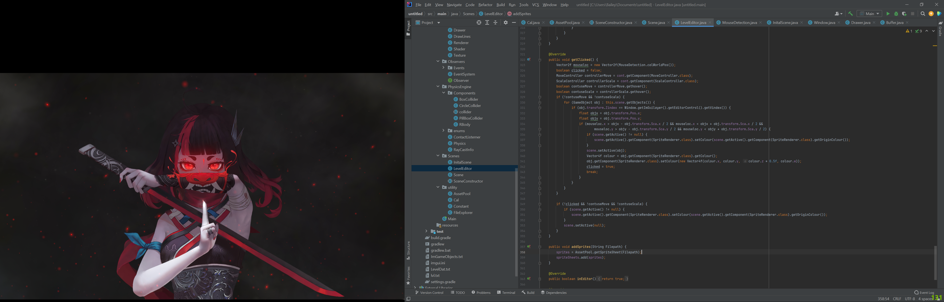

Import Window Method (imgui()) in levelEditor:

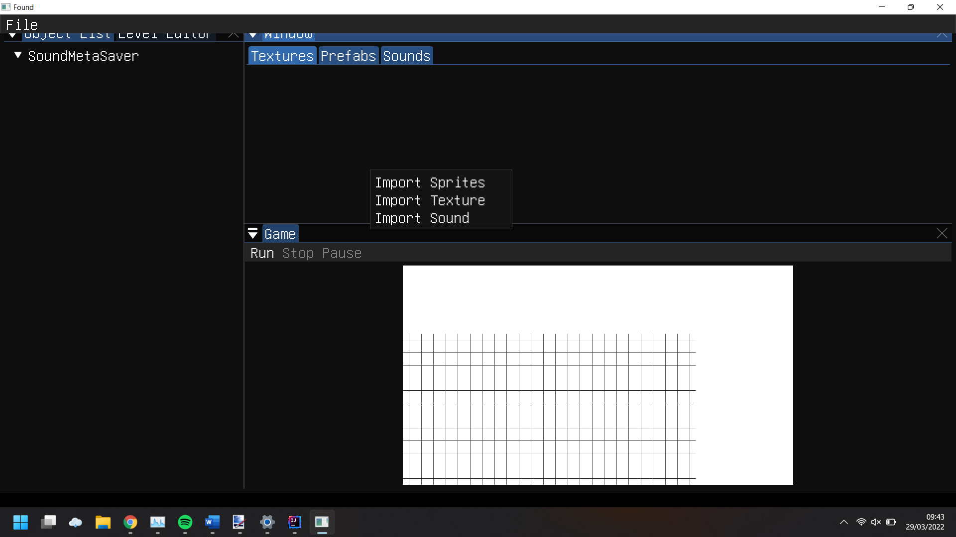(Popup Window) This method will handle all of the importing of objects. The code below created the popup window shown here. When one of these are selected, a fileExplorer is opened so you can locate the file you want to import. If a valid file is selected, it si copied into the assets/sound folder in the games folder. This then sets the ImportWindow Class to active, showing each respective window Import type (shown in the design).

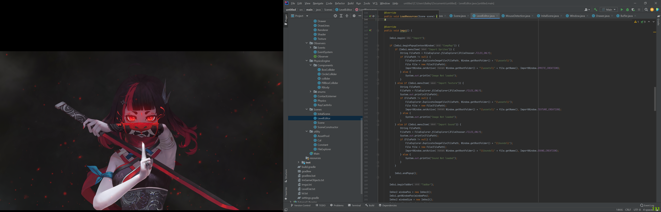

Main Import Window (same method):

This part of the method displays the images/sound names of the imported files. Firstly is the textures tab. As each spritesheet, which is where all the textures are stored, is linked to a single texture, an array of these is created. This array is looped through, creating a “collapsing header” which shows the textures for that image when triggered. Example: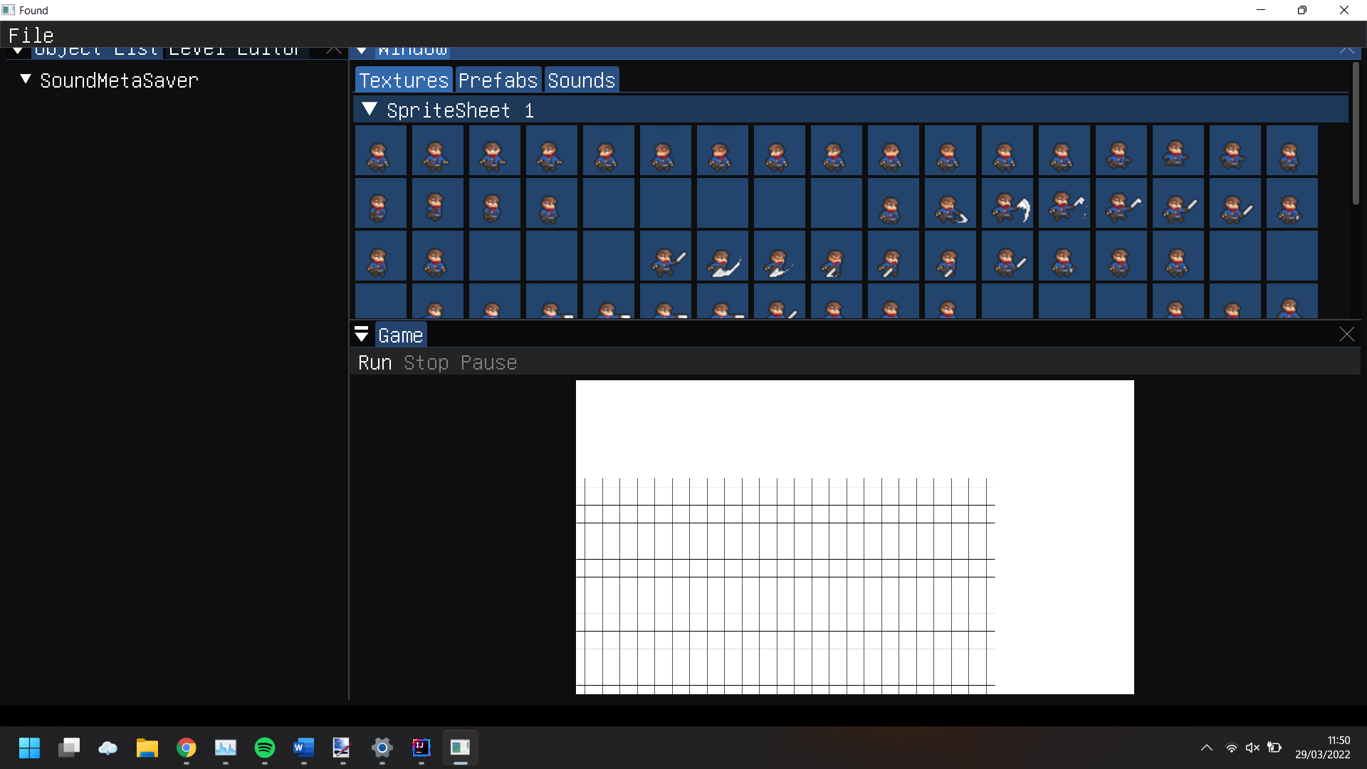

For each spritesheet, 3 boolean values are set for the components to be added to each texture when imported into the viewport. These values are set when importing an image into the game and saved to the imageSaveComp. The components in imageSaveComp are looped through until the name of the image saved in the component equals the spritesheets texture name. then each header is given an label (which works like an id). We check to see if the header has been opened, returning true. If it is true, we create image buttons for each texture in that spritesheet. I taught that creating the button with the width of a single sprite was too small and could be hard to tell the difference between textures, so I scaled them up by a factor of 2. When creating an image button, we need to pass through the texture id of the texture. We also need to pass in the texture coordinates to tell OpenGL what part of the image we want. Then a button is created with a unique id for that button so when pressed imgui knows which button was pressed. If a button is pressed, a GameObject is created, passing in the sprite, the width and height of the object and the current Z value. I used 0.25 for the width and height as each square in the viewport is that size and the physics engine, I’m using works best with small scales of objects. Then, depending on what components were selected when creating the textures, they are added to the object created. I also did not allow a circle/box collider to be added to an object unless it has a rigidBody (RBody) as these colliders are used as hitboxes for the physics engine and are useless without a rigidBody. This object is then set as the current active object and is mapped to the mouse position. the width of the buttons together are calculated, adding each buttons width to a total width of all the buttons. If there is space for the next button on the same row, then imgui is told to add the next item on the same line. If there is no space, the next button is put on the row below.

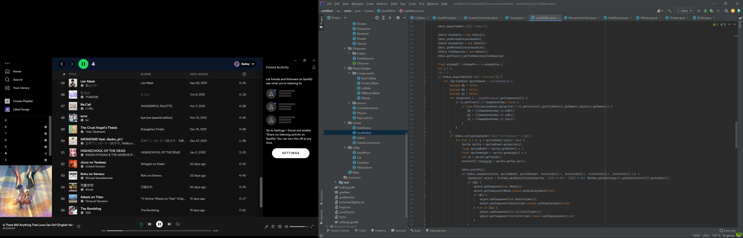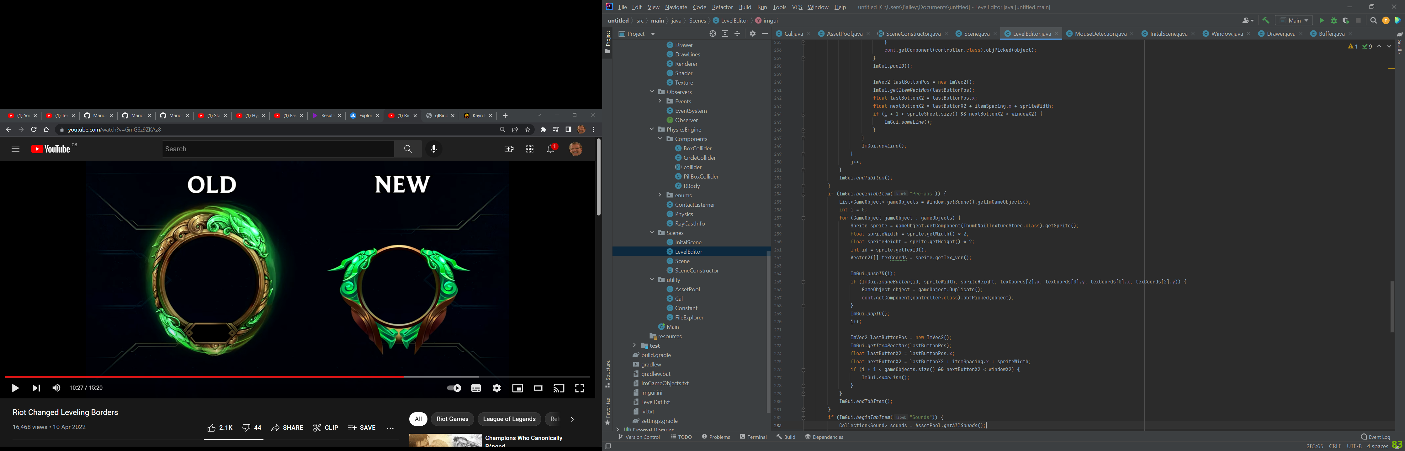

For the next tab “prefabs”, stores all the sprites created when importing sprites, allowing you to add them to the Viewport. These are stored in a separate array of GameObjects and saved in a different file. When clicked, that buttons respective gameObject is duplicated and set as active. The setup of the button is basically the same as the setup of the textures in the previous tab. The texture for these game objects are set when importing them as you choose the image you want to set as the thumbnail of the game object when in the import window, stored in the thumbnailtexturestore component. The buttons are displayed the same as the textures tab, calculating the width of all the buttons, making them on the same line if there is space.



For the sounds tab, a Collection of Sounds is stored in the AssetPool. We retrieve this collection, looping through all the Sounds in sounds. A temporary file is created, set with the filepath of the current sound in the loop. A text button is created, labelled with the sounds file name. if this button is pressed, there is a check to see if the sound is playing. If it is not playing, the sound is then played. If the sound is already playing, the sound is stopped. The layout of the buttons is calculated by getting the space available on the current line. If it is less than 100, the next button will be on a new line.

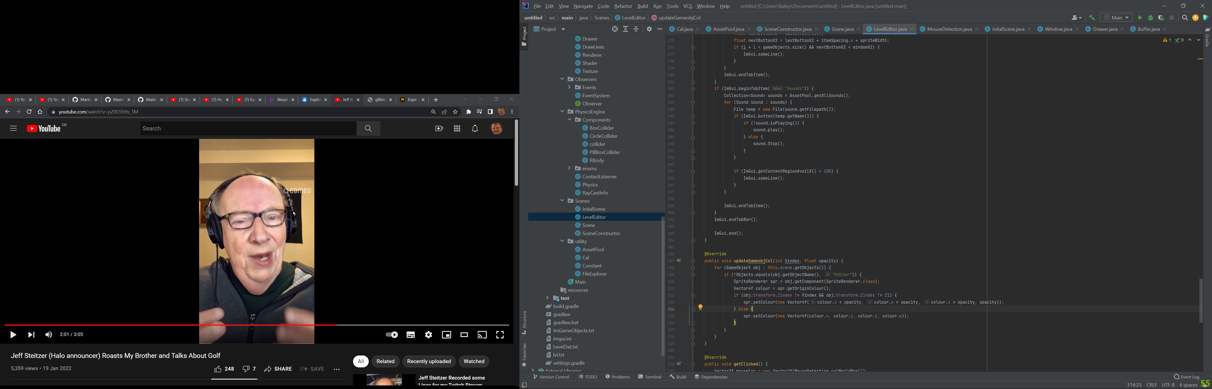

GameObject() class:

Duplicate Method:

This is used when you want to copy an item, used in the import window above and when placing an object in the scene. When copying an object you cannot just set a variable to equal the object you want to copy as this just stores it as a reference to the original object. The way I copy an object is to serialize it into the json format. This is then deserialized and created as a new object, creating new ids for each component and the gameobject. this gameobject is checked to see if it has a texture. If it does then the new object is set with the texture of the original object and returned.

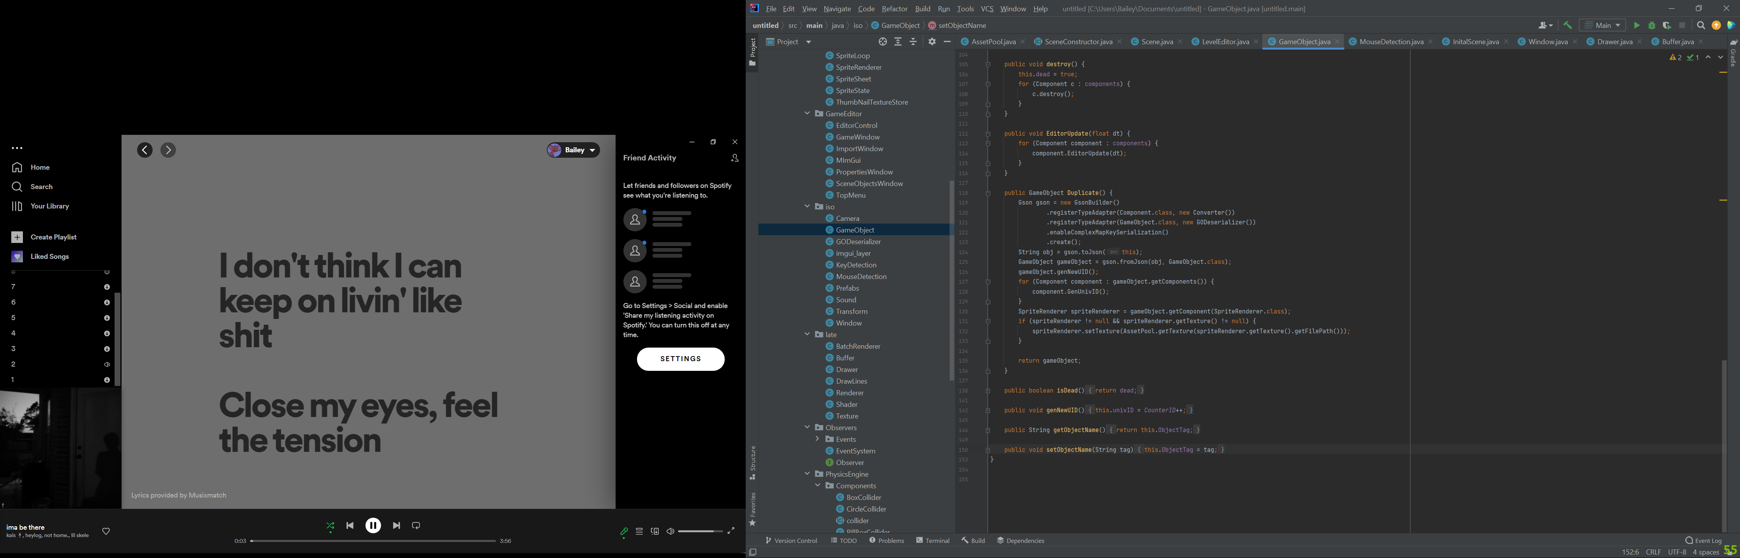

Component Class:

Imgui() method:

This method applies to all component subclasses unless overridden. This method is for displaying fields in each component class in the window. These variables can then be changed in the window. This is in a try catch so if an error happens the user can see what line it errored at and why. Firstly, an array of fields is created, getting all the fields of the class. Then a for loop is run, looping through all the fields. 2 Boolean values are created for attributes of the field, Transient and private, if we label a field as transient, it is not displayed as we do not want this variable to be edited. If the variable is private, we cannot change it freely, so we need to set it to accessible. Then a generic Class variable is created, set to the fields class. This is the same for the data of the field. Finally, the name of the field is stored as a string. This can be used as a label in imgui to tell the user what variable they are editing. The data variable is then checked to make sure we aren’t trying to edit a null variable as this will throw errors from Imgui. A long if statement is used for each class used. This is to tell imgui how to display data as there are different ways of displaying each type of data. The variable is then set back to inaccessible if it is a private variable.

